|  |  |
| --- | --- |
| Internship Project Title | **RIO-125: Real Time Chat Application - Develop a MEAN Stack Application with User-Specific Features** |
| Name of the Company | TCS iON |
| Name of the Industry Mentor | Debashis Roy |
| Name of the Institute | ICT Academy of Kerala |

|  |  |  |  |  |  |  |
| --- | --- | --- | --- | --- | --- | --- |
| Start Date | End Date | | Total Effort (hrs.) | | Project Environment | Tools used |
| 25-06-2023 | 09-07-2023 | | 58 | | VS Code, Windows, Firefox | NodeJS with Express, MongoDB Atlas, Postman |
| Milestone # | 2 | Milestone: | | Completed: User Dashboard, Chat box, Mechanism to mute and block users, Stored messages on backend | | |

**TABLE OF CONTENT**

* **Acknowledgements**
* **Objective**
* **Introduction / Description of Internship**
* **Internship Activities**
* **Approach / Methodology**
* **Flow Diagram**
* **Reflections on the Internship**
* **Enhancement Scope**
* **Link to code and executable file**

# **Acknowledgements**

I thank TCS ion and the industry mentor for their guidance and support as well as for providing necessary information regarding the project.

# **Objective**

The objective of this project is to develop a real-time chat application using the MEAN stack (MongoDB, Express.js, Angular, and Node.js). The application will provide user-specific features and enable real-time communication between users.

# **Introduction/Description of Internship**

The internship opportunity offered by TCS iON (Tata Consultancy Services iON) provides students with a valuable learning experience in the field of software development and project management. During the internship, students will have the opportunity to work on a real-world project, gaining practical knowledge and skills that will enhance their understanding of software development processes.

This project involves the development of a Real Time Chat Application using the MEAN stack (MongoDB, Express.js, Angular, and Node.js). The project aims to create a user-friendly and efficient chat application that enables real-time communication between users. It will also incorporate user-specific features such as message search, notification settings, and chat preferences.

# **Internship Activities**

Some of the activities to be done during the internship include Pre-project test, activity report, interim project reports, final project report, project test.

# **Approach / Methodology**

1. Initially we create a backend server to serve and process requests from the client.
2. The backend communicates with the database and retrieves / stores information.
3. For this project I have used MongoDB Atlas which is a MongoDB hosted in the cloud.
4. We then model the data items to be stored in the database. This is done with the mongoose package which helps in data modeling for MongoDB.
5. The models are defined with mongoose schemas.
6. The models are made for user signup, message storing
7. Make controllers for the above models to get, post or update information regarding the models.
8. The frontend is made with Angular JS.
9. The frontend communicates with the backend by making get/post and other methods of requests to enable the various functions of inventory management
10. New users can register, logged in users can add friends to chat, loaded the previous conversations.
11. User can mute, block their friends.
12. The landing page is designed to be a dashboard that includes the chats.

# **Flow diagram**

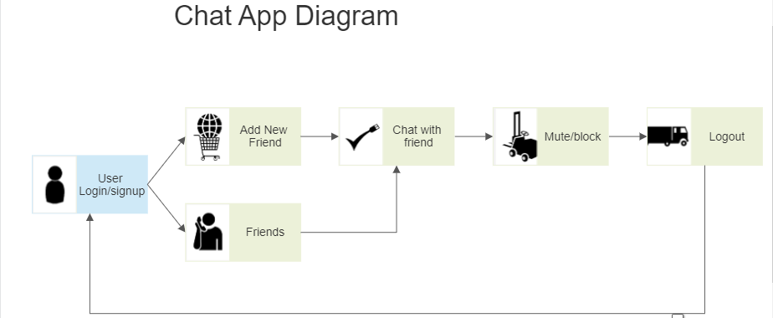

**Reflections on the Internship**

I'm hoping that working as an intern with TCS ion will allow me to gain greater knowledge of the MEAN stack and referred many documents about message sending using socket connection.

# **Enhancement scope**

There is a lot of scope for improvement of the chat module.

# **Link to code**

**GitHub repository with documents submitted till now and also the code for the project:**

**Backend code :** [**https://github.com/parvathy214/chatapp-backend**](https://github.com/parvathy214/chatapp-backend)

**Frontend code :** [**https://github.com/parvathy214/chatapp-frontend**](https://github.com/parvathy214/chatapp-frontend)